**What Makes People in a Country Happy?**

CSE 519 Final Project

1. **Introduction & Background**

Happiness is a difficult concept to measure, and there is a large body of research dedicated to finding adequate ways of conceptualizing happiness [1][2]. Much research is also dedicated to figuring out exactly what makes people happy. Chief among this body of work is the World Happiness Report (WHR) [3], which attempts to create a happiness ranking for each country around the world. Published by an international group of researchers in collaboration with the United Nations, this report relies on a combination of self-reported well-being indicators and objective measures. Each country is assigned a happiness score, and the countries of the world are then ranked according to how happy their citizens are. Data for the WHR is sourced from a combination of the World Bank, the World Health Organization, and the Gallup World Poll.

The WHR remains an authoritative voice in the field of cross-national research, and it’s rankings are widely cited by scholars and policy-makers. Each year, the WHR provides a thorough analysis of what makes the citizens of the world happy, discussing happiness as it relates to a variety of different factors. Despite the in-depth analyses contained within the report, the rankings themselves are very simple to calculate. Eight metrics are used to calculate the Happiness Index of a given nation: Log GDP per capita (provided by the World Bank), life expectancy at birth (provided by the World Health Organization), and the following self-reported well-being indicators: social support, freedom to make life choices, generosity, perceptions of corruption, positive affect, and negative affect.

However, there are a number of potential problems with the WHR as it currently exists. For one thing, Gallup World Poll data is highly expensive to access (getting access to that data requires a lot of money and institutional backing), thus it is difficult for researchers to independently validate it and point out potential problems. Self-reported measurements are notoriously changeable, and a self-report measurement that is difficult to validate makes it hard to detect potential problems with the data or measurements. There are potential substantive problems with the report as well, and there has been some debate among scholars as to how accurate the WHR’s indices are. The report has been subjected to a range of methodological critiques. Some have argued that the methods used to calculate their indices are flawed [4][5] , while others have attempted to create measurements of happiness that focus on marginalized citizens [6][7].

Our work attempts to address some of these criticisms by creating a better metric to measure the happiness of citizens around the world. We attempt to do this by incorporating variables that the WHR overlooks in calculating their rankings. We attempt to create a new scoring function that relies on a wider range of well-being indicators than that of the WHR. We build multiple models which incorporate different calculation methods, and seek to understand if the inclusion of different variables illuminate any new patterns in what effects cross-national happiness. In the subsequent sections, we discuss our data sources, cleaning and preprocessing steps, followed by our methodological approach and results.

1. **Data Sources**

We combine the data used to calculate the WHR 2020 happiness indices (publicly available via the WHR’s website) with other variables obtained from the following sources:

**The World Bank:** A global lending organization that funds a wide range of development projects, the World Bank makes its repository of data available to scholars working on cross-national projects. The data pertains to a wide variety of social and economic indicators and is relied upon by cross-national researchers across disciplines.

**United Nations Human Development Data:** The United Nations publishes a wide variety of indicators as part of the UN Human Development Programme. While primarily used to calculate the annual UN Human Development Indices for each nation, this data is a valuable source for cross-national research projects.

We incorporated the following variables into our scoring function, in addition to the variables provided in the WHR (variables are listed as they appear in our notebook, followed by description and data source):

* ***Maternal_mortality_ratio_per100k****:* Number of maternal deaths per 100K births [World Bank]
* ***Adolescent_fetility_per1k****:* Fertility rate among girls ages 15-19, per 1K girls   
  [World Bank]
* ***School_secondary_enrollment_gpi****:* The ratio of girls to boys enrolled in secondary school in a nation [World Bank]
* ***Women_seats_parliament****:* Percentage of parliamentary seats held by women   
  [World Bank]
* ***Literacy_rate****:* Adult Literacy Rate (% of population age 15 or over) [World Bank]
* ***Natural_resource_depletion****:* Percentage of GNI lost to natural resource depletion   
  [UN Human Development Data]
* ***Life_expectancy****:* Life expectancy at Birth, in years [UN Human Development Data]
* ***Income_inequality****:* GINI Coefficient   
  [UN Human Development Data]
* ***Female_suicide_per100k****:* Female suicides per 100K people   
  [UN Human Development Data]
* ***Male_suicide_per100k****:* Male suicides per 100K people [UN Development Data]

We chose to include these variables in our model for a number of reasons, but namely because we felt that they are likely to have a meaningful effect on the happiness of citizens in a given nation. Many of these are likely to disproportionately impact developing nations, and thus it is possible that our model will paint a very different picture of national happiness than the WHR. Our choice of metrics pertaining to gender were also informed by previous criticisms of happiness, which argue that gendered variables matter when considering happiness of citizens.

1. **Methods**
2. *Data Cleaning*

When cleaning the data, we first accounted for countries listed under different names in the different datasets. We made a file with country name corrections by dataset (full analysis is available in the folder ‘02 Cleaning’). Along with this, each country has an ID added to it to accommodate the visualization. We merged our existing data sources into one dataset, accounting for countries that were listed under different names by merging them under one listing. A control file was made which handles what variables are to be taken from what dataset and look back from which year; this csv file is easily editable and helps to add new variables dynamically on the go.

We impute missing values based on the most recently available data. For example, if an indicator is not available for 2019, we impute it with the 2018 value, or 2017 if 2018 is not available. If data for that country/variable pair is not available from within the past five years, we impute the missing value with the column mean. All variables are normalized before calculating our scoring functions.

1. *Scoring Functions*

We incrementally built multiple scoring functions, where each scoring function helped us refine our analysis and come up with more relevant parameters to help build a robust function. On a high level, we have divided them into 4 types, but these have helped us build 14 different scoring functions.

1. ***Baseline Function***: After cleaning, we merge the existing WHR ladder score with our new variables to create a new happiness index for each country. Our baseline function takes the existing WHR ladder score (synonymous with the Happiness Index, and calculated by adding the values of each source variable together) and adds our baseline variables to this score. We sum the “positive” variables (Secondary school enrollment GPI, adult literacy rate, and the number of seats in parliament held by women), or metrics that we predict will positively affect well-being with those that should negatively affect well-being ('maternal mortality ratio per 100k', 'adolescent fertility per 1k', 'natural resource depletion', 'income inequality', 'female suicides per 100k', and 'male suicides per 100k').
2. ***Baseline Weighted***: We realized that not all of our variables contribute equally to the final outcomes, so we decided to weight each variable by their importance. To attain the weights, we did a correlation analysis of our variables to the WHR scores. Our big find here was while female suicides affect happiness negatively, male suicides had a positive but very low correlation (<0.014) with the country's happiness. The weights automatically provide negative or positive affect due to the correlation value. These are multiplied with a scaler to normalize with the ladder score so that the ladder score is not given a higher importance over our variables. The weights are multiplied by the normalized values before adding to the ladder score, giving us our new function score.
3. ***Grouped Function***: To analyze how country rankings perform when grouped by their geographical regions, we utilized the region definitions available by WHO, World Bank, and Angus Maddison[8]. To conduct a custom analysis on a few more regions, we created a custom group mapping by regions, which primarily depends on the continent they belong to. We added some small, but notable regions of interest like the Middle East, the Balkans, Nordic countries and Caribbeans, to help us focus on their outcomes. This also helped to balance the group they previously belonged to by not affecting them in further analysis. The breakdown of each country by its grouped region is available in the ‘all_countries.csv’ file in the ‘raw data’ folder. First, we grouped the countries by these regions and found a mean for their WHR ladder score and baseline variables for each of the regions. Further, we calculated a baseline function score for each region and compared this. This helped to show whether a region’s overall rank would change with our variables, and we saw a consistent change in regions like both the American continents and east Asia.
4. ***Grouped Weighted Function***: We believed it wasn’t fair for each country to have the same weight assigned to the baseline variables, as sometimes it's hard to compare two countries on a single variable. For example, while comparing a developed country, GDP per capita is not a good comparison metric, rather, the cost of living per capita by GDP per capita would be a fairer comparison. To achieve this, we decided to use our region mapping and use those to get new weights for each country. Now, the weights for each country would depend on which group they belong to. We used the Grouped Function along with the Baseline Weighted function to achieve this. This helps to compare countries at a group level and attain a robust weight for each of the variables.

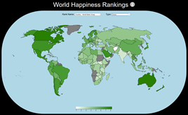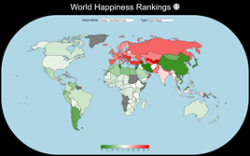

Figure 1: (top) Display of WHR Rankings plotted on world map. Green represents higher-ranked countries and white is lower ranked countries. (bottom) relative change in happiness ranking after scoring function applied. Red indicates negative change (country getting happier) while green indicates positive change (country getting less happy

1. *Visualizations*

We have created a dynamic website visualization in which we publish the results of our various scoring functions, in the form of function score and country rank. Viewing that website also shows the changes between the WHR’s happiness ranking as well as our various models, and it makes it easy to discern patterns in happiness ranking by region of the world. This website displays a map of the world, and each country’s happiness ranking according to both the WHR and our models are displayed there. The display is color-coded similarly to a heat-map, with the highest-ranked countries displayed in green, and lower-ranked countries displayed in white (see Figure 1). This visualization is hosted using Github Pages for free and is available [here](https://ob-0ne.github.io/worldMapHappiness_visualization/?fbclid=IwAR366KVrn1wElqxmn9ZT4V95Kh40zcyJn7VSo0SiznUk6s3sviWD56HXYDQ).

The visualization dashboard was made using HTML, CSS, and some JavaScript libraries (d3 and jQuery). We acquired a free SVG representing the world map from [9]. Each country’s SVG has a specific id which has been added to the data in the cleaning step. The website has two dropdowns to help select the model or scoring function and their analysis variables respectively. Countries whose data was unavailable either in WHR or our dataset sources have been greyed out. The full code is accessible on our [github](https://github.com/OB-0ne/worldMapHappiness_visualization).

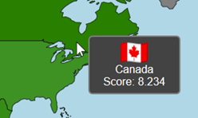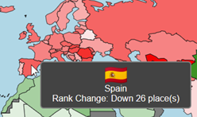

Figure 2: (top) Display of Canada’s happiness ranking on world map visualization. (bottom) Display of Spain’s change in rank after scoring function is applied

Each country has a hover event, which helped to show more details about the current country for the currently selected options in the dropdown. Custom colormaps are generated on the go to show single color (green to white) or multi-color (green to red) depending on the variable and their ranges. There is also an information tooltip which can help the user understand and navigate our website.

1. **Results**

We begin by examining the data from the 2020 World Happiness Report and outlining key patterns, before discussing the results of our models. For brevity’s sake, we report findings that we feel are substantively interesting in this paper, and a full breakdown of our various scoring functions can be found in the supplemental materials attached to our submission. Data and results for all of our scoring functions are reported there.

1. *Happiness According to the WHR*

First off, there is a relatively stable pattern in happiness around the world over time. European and North American countries (and the Nordic countries specifically) are consistently ranked near the top, whereas African and Asian countries tend to be closer to the bottom. This is unsurprising when we consider the histories of these regions and the cumulative disadvantages that some Asian and African countries face because of it.

The WHR also notes that there is a very large gap in happiness scores between highly-ranked nations and lower-ranked nations; the top countries’ scores are more than twice as high as the bottom countries. The data from the WHR suggests that certain regions are experiencing long-term changes in happiness; the authors note that the Middle East, South Asia, and Sub-Saharan Africa are experiencing long-term declines in happiness.

These regional trends should be of interest to scholars of cross-national happiness. They are indicative of patterns, however to what extent these patterns are measurement-specific is the question we attempt to answer with our models.

1. *Model Results*

Figure 3 displays the change in national happiness rankings for our baseline scoring function. We present the changes in happiness rankings in three different ways: a scatterplot which plots the WHR Happiness Indices with our baseline model, and two histograms showing the absolute and relative change in rank. Our new scoring function presents an interesting pattern; noticeably, the top and bottom countries remain relatively stable and do not change. However, there is a lot of variation among nations whose happiness scores rank in the middle, with some countries getting significantly happier, and some becoming significantly less happy.

Table 1 displays the nations with the 10 largest positive and negative changes in happiness rankings after implementing our baseline model. There appears to be a pattern of substantive interest here; notably, the highest negative changes largely come from countries located in the Balkan region and southwestern Europe. The highest positive changes come from countries located in South America and Africa. Thus, the Balkan countries and nations in south-western Europe seem to be getting happier by including additional variables, whereas countries in South America are getting less happy. This is indicative of a potential flaw in the WHR’s rankings. Because we can observe a notable fluctuation in happiness by region, we can postulate that the omission of certain variables from the World Happiness Report may lead to the inflation in happiness among certain regions of the world, whereas other countries are pushed towards the bottom.

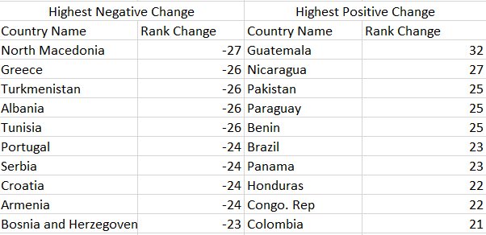

Table 1: Results of baseline scoring function (Function A). Highest negative (left) and highest positive (right) changes in happiness rankings from WHR index

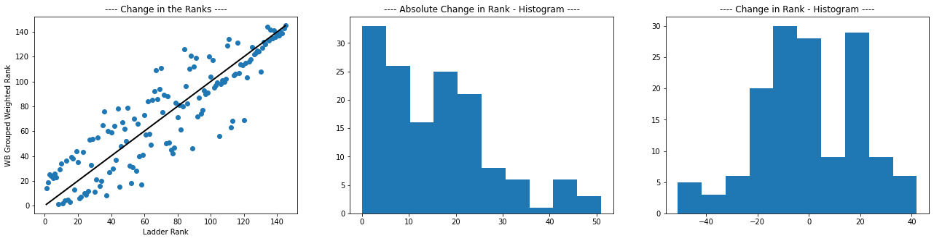 After implementing our baseline scoring function, we experimented with different methods of weighting our predictor variables to calculate our indices. We were interested in continuing to explore regional patterns in the data, and thus we introduced a regional weight to account for these patterns. Figure 4 above depicts a scatterplot showing the changes in happiness rankings for each nation after regional grouping is applied. The results of this model are even stranger; there is still a large amount of variation among countries ranked in the middle of the world, however instead of the bottom half being as stable as the top half, this time there is a wider fluctuation around the top cluster of countries as well.

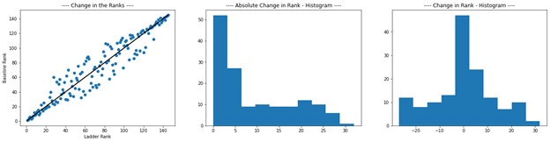

Figure 3: Change in Happiness ranking after baseline scoring function. From left to right: scatterplot, histogram showing absolute change in rank, histogram showing relative change in rank



In this model, there is again a clear pattern by region. Asian and European countries appear to get significantly happier (their ranks decrease as compared to the WHR), and African, South American, and North American countries increase their rankings (meaning that they get less happy). This disrupts the WHR’s findings that the WHR remains stable over time. When additional variables are taken into account, these countries see a notable decrease in their happiness score.

1. **Discussion**

What do these findings mean? For one, our results indicate that our suspicions may be correct; previous criticisms of the World Happiness Report may indeed have merit. The inclusion of additional variables that the WHR overlooks may indicate a disproportionate skew in national happiness rankings. Our findings suggest that, to some extent, the insights provided by the WHR may be measurement-specific. That is, the omission of certain metrics may create a bias in cross-national happiness rankings in favor of European countries, and it is potentially a result of this bias that certain countries remain near the top of the happiness list.

It is unclear from these results in which direction this bias skews. In some of our models, happiness rankings of European countries seemed to be decreasing (suggesting an inflated ranking in the WHR), and in others of our scoring functions, it seems that the rankings of South America and Africa increase substantially (suggesting that the WHR measurements increase the happiness rankings for these countries). It is tempting to argue for a Eurocentric bias in the WHR since eurocentrism has long been a problem in research [10][11]. However, based on these results it is not possible to draw a firm conclusion as to whether this is really occurring.

Though it is not possible to draw a firm conclusion as to which direction these biases go, we can conclude that our variables do present a substantial relationship to the self-reported well-being of citizens in a nation. Scholars had previously found that metrics related to gender have an effect on self-reported happiness [7] and our results also show this to be the case. Our results also suggest that factoring in additional measurements related to *negative* outcomes (notably, the female and male suicide rates for a given nation) have an effect on national happiness. Based on this, we argue that, at the very least, the WHR should explore the possibility of controlling for additional measurements when calculating their happiness indices. They should incorporate metrics other than simply GDP and life expectancy at birth and include controls for education-related variables, variables specifically relevant for marginalized populations (such as women), and additional measurements related to negative affect.

It is also a possibility that these differences are due to measurement error, and the WHR’s methodologies are sufficient to withstand its critics. Future research should continue to investigate alternative methods of measuring happiness, and scholars should continue to investigate what factors relate to happiness around the world. Researchers should also continue to critique the WHR and should investigate the variables utilized in our model for their relationship to happiness.

1. **Conclusion**

In this paper, we have attempted to build upon existing World Happiness Report data by introducing additional factors that influence citizens’ self-reported well-being. We have built a number of different models to study happiness around the world, and we have shown that including additional variables can lead to patterns that are substantively interesting. We argue that, to some extent, many of the findings in the WHR may be measurement-specific, and that omitting certain variables that correlate with happiness may artificially inflate the happiness levels of certain countries of the world while skewing other regions towards being less happy. We believe that our results can help illuminate additional factors which affect cross-national happiness and encourage future scholars of happiness to consider taking some of these variables into consideration in their own work on the subject.

**References**

1. Linley, P. Alex, John Maltby, Alex M. Wood, Gabrielle Osborne, and Robert Hurling. 2009. “Measuring Happiness: The Higher Order Factor Structure of Subjective and Psychological Well-Being Measures.” *Personality and Individual Differences* 47(8):878–84. doi: [10.1016/j.paid.2009.07.010](https://doi.org/10.1016/j.paid.2009.07.010).
2. Dambrun, Michaël, Matthieu Ricard, Gérard Després, Emilie Drelon, Eva Gibelin, Marion Gibelin, Mélanie Loubeyre, Delphine Py, Aurore Delpy, Céline Garibbo, Elise Bray, Gérard Lac, and Odile Michaux. 2012. “Measuring Happiness: From Fluctuating Happiness to Authentic–Durable Happiness.” *Frontiers in Psychology* 3. doi: [10.3389/fpsyg.2012.00016](https://doi.org/10.3389/fpsyg.2012.00016).
3. Helliwell, John F., Richard Layard, Jeffrey Sachs, and Jan-Emmanuel De Neve, eds. 2020. World Happiness Report 2020. New York: Sustainable Development Solutions Network <https://worldhappiness.report/ed/2020/>
4. Carlsen, L. (2018). Happiness as a sustainability factor. The world happiness index: A posetic- based data analysis. Sustainability Science, 13(2), 549–571. https://doi.org/10.1007/s11625-017-0482-9
5. Carlsen, L. (2020). How Happy Are we Actually? A Posetic Analysis of the World Happiness Index 2016–2019 Denmark as an Exemplary Case. International Journal of Community Well-Being, 3(3), 311–322. <https://doi.org/10.1007/s42413-019-00044-8>
6. Berggren, N., Bjørnskov, C., & Nilsson, T. (2017). What Aspects of Society Matter for the Quality of Life of a Minority? Global Evidence from the New Gay Happiness Index. Social Indicators Research, 132(3), 1163–1192. https://doi.org/10.1007/s11205-016-1340-3
7. Kabene, S., Baadel, S., Jiwani, Z., & Lobo, V. (2017). Women in Political Positions and Countries’ Level of Happiness. 18(4), 10. https://vc.bridgew.edu/jiws/vol18/iss4/15/
8. World map region definition by Diane Beltekian, Our World of Data website, [https://ourworldindata.org/world-region-map-definition](https://ourworldindata.org/world-region-map-definitions)
9. Free World SVG Map by simplemaps, <https://simplemaps.com/resources/svg-world>
10. Miike, Yoshitaka. 2007. “An Asiacentric Reflection on Eurocentric Bias in Communication Theory.” *Communication Monographs* 74(2):272–278.
11. Joseph, George Gheverghese, Vasu Reddy, and Mary Searle-Chatterjee. 1990. “Eurocentrism in the Social Sciences.” *Race & Class* 31(4):1–26.
12. Our Code Nodebooks and files, Github: <https://github.com/OB-0ne/worldHappinessAnalysis_comparingWHR>
13. Visualization code, Github: <https://github.com/OB-0ne/worldMapHappiness_visualization>